Steps for migrating to Sabre environment:

1. Get SGID
2. Log in to Sabre Teams and Sabre Mail
3. Get the Autopilot done. For getting it done, follow the steps from BYOD(Bring your own device) document which will be shared beforehand.
4. Raise the access for bitbucket git, nexus and SNOW from Service Now Portal.

**Service Now** -: <https://sabre.service-now.com/>

**Self Service ->Request Catalog ->Sabre Data Center Services ->** [**NextGen Platform Services**](https://sabre.service-now.com/com.glideapp.servicecatalog_category_view.do?v=1&sysparm_parent=896f6bd4dbcb57c475dd9837db9619e4&sysparm_no_checkout=false&sysparm_ck=1cfaf0741b353c10116c2f46624bcbf0c29c991e9a1992f962d0982a46abccd591c498b5&sysparm_view=catalogs_default&sysparm_catalog=75c39ff81b5224546ce4cbbe034bcb6b&sysparm_catalog_view=catalog_sabre_data_center_services) **->  NGP Developer Onboarding**

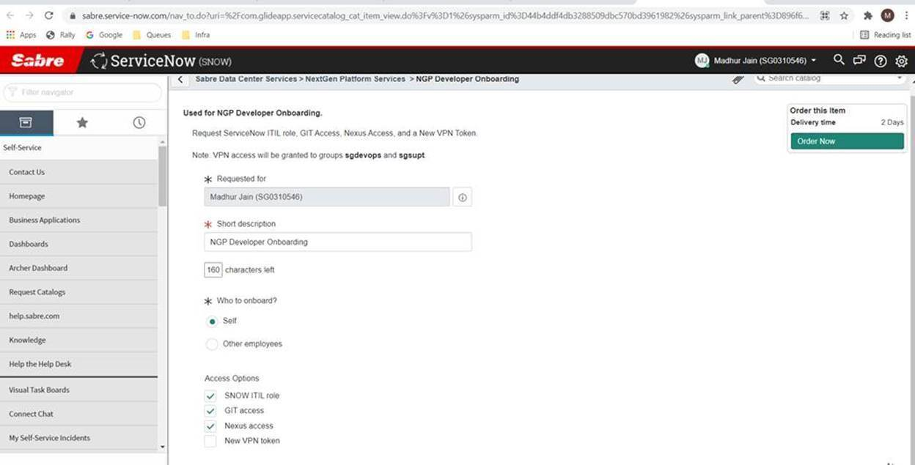

1. Get the following Softwares installed from <https://euc.sabre.com/apps>:

**Request Software for Windows -> Applications**

* IntelliJ community addition
* Maven
* 7 Zip
* Notepad ++
* Hyper  V
* Docker
* Git
* Java 11
* Git Extensions
* Postman
* Google Cloud SDK
* Winmerge

If <https://euc.sabre.com/apps> is not accessible, try opening the link in Inprivate/Incognito mode. Click on ‘Use a different account’ and login with Sabre credentials.

1. Get GCP and Prisma access: <https://sailpoint.sabre.com/identityiq/home.jsf>

Click on **Manage My Access** and select the following accesses.

Search by first access, Add it and then search by the next. After adding all 8 accesses, click on Next and Submit.

* gcp-sab-dev-fsn-db-rsv-que-appdbas
* gcp-dev-reservations-gkesres
* gcp-dev-reservations-developers
* gcp-sab-dev-spn-db-gpd-appdbas
* gcp-sab-dev-spn-db-gpd-viewers
* **PrismaAccess-Dev**
* **PrismaAccess-Prod**
* **PrismaAccess-Cert**

7)Get BIT bucket access:

[reservationshttps://git.sabre.com/projects/SABRE2/repos/sabre2/browse//queues](https://git.sabre.com/projects/SABRE2/repos/sabre2/browse/reservations/queues)

If the link is not working, Please call BLR Toll Free - 000800 1008770 or raise a SNOW ticket.